**Assignment no 1**

<head>

<title>QTRAX</title>

<link rel="stylesheet" href="">

<style>

.navbar {

overflow: hidden;

background-image: url("Guitar.jpg");

font-family: Segoe print;

background-position:top;

background-size:100% 100%;

}

.navbar a {

float: left;

font-size: 16px;

color: Orange;

text-align: center;

padding: 14px 16px;

text-decoration: none;

}

.dropdown {

float: left;

font-size:16px;

overflow: hidden;

color:Orange;

padding:14px 16px;

}

.dropdown .dropbtn {

font-size: 16px;

border: none;

outline: none;

color: Orange;

padding: 14px 16px;

background-color: inherit;

}

.navbar a:hover, .dropdown:hover .dropbtn {

background-color: Blue;

}

.dropdown-content {

display: none;

position: absolute;

background-color: White;

min-width: 160px;

box-shadow: 0px 8px 16px 0px rgba(0,0,0,0.2);

z-index: 1;

}

.dropdown-content a {

float: none;

color: Blue;

padding: 12px 16px;

text-decoration: none;

display: block;

text-align: left;

}

.dropdown-content a:hover {

background-color:Brown;

}

.dropdown:hover .dropdown-content {

display: block;

}

<meta name"viewport" content="width=device-width,initial-scale=1">

::-webkit-scrollbar{width:10px;}

::-webkit-scrollbar-track{backgroungd-image:"Guitar.jpg";}

::-webkit-scrollbar-thumb:hover{background:#555;}

::-webkit-scrollbar-thumb{background:#888;}

input[type=text], input[type=password] {

width: 100%;

padding: 12px 20px;

margin: 8px 0;

display: inline-block;

border: 1px solid #ccc;

box-sizing: border-box;

}

button {

background-color: #4CAF50;

color: white;

padding: 14px 20px;

margin: 8px 0;

border: none;

cursor: pointer;

width: 100%;

}

button:hover {

opacity: 0.8;

}

/* Extra styles for the cancel button */

.cancelbtn {

width: auto;

padding: 10px 18px;

background-color: #f44336;

}

/* Center the image and position the close button */

.imgcontainer {

text-align: center;

margin: 24px 0 12px 0;

position: relative;

}

img.avatar {

width: 40%;

border-radius: 50%;

}

.container {

padding: 16px;

}

span.psw {

float: right;

padding-top: 16px;

}

/* The Modal (background) */

.modal {

display: none; /* Hidden by default */

position: fixed; /* Stay in place */

z-index: 1; /* Sit on top */

left: 0;

top: 0;

width: 100%; /* Full width */

height: 100%; /* Full height */

overflow: auto; /* Enable scroll if needed */

background-color: rgb(0,0,0); /* Fallback color */

background-color: rgba(0,0,0,0.4); /* Black w/ opacity */

padding-top: 60px;

}

/* Modal Content/Box */

.modal-content {

background-color: #fefefe;

margin: 5% auto 15% auto; /* 5% from the top, 15% from the bottom and centered */

border: 1px solid #888;

width: 80%; /* Could be more or less, depending on screen size */

}

/* The Close Button (x) */

.close {

position: absolute;

right: 25px;

top: 0;

color: #000;

font-size: 35px;

font-weight: bold;

}

.close:hover,

.close:focus {

color: red;

cursor: pointer;

}

/* Add Zoom Animation */

.animate {

-webkit-animation: animatezoom 0.6s;

animation: animatezoom 0.6s

}

@-webkit-keyframes animatezoom {

from {-webkit-transform: scale(0)}

to {-webkit-transform: scale(1)}

}

@keyframes animatezoom {

from {transform: scale(0)}

to {transform: scale(1)}

}

/* Change styles for span and cancel button on extra small screens */

@media screen and (max-width: 300px) {

span.psw {

display: block;

float: none;

}

.cancelbtn {

width: 100%;

}

}

</style>

</head>

<body bgcolor="303030">

<div class="navbar">

<nav>

<div class="brand-name">

<h1>

<marquee><span><img src="MusicLogo.jpg" alt="" width="30" height="30" ><font face="segoe print" size="7" color="Orange">QTRAX</marquee></font></span>

</h1>

</div>

<ul>

<a href="#home" >Home</a>

<a href="#worldwide">Worldwide</a>

<a href="#artists">Artist Manifesto</a>

<a href="#Media">Media</a>

<div class="dropdown">Days Special

<div class="dropdown-content">

<a href="#">Mother Day</a>

<a href="#">Father Day</a>

<a href="#">Valentine Day</a>

</div>

</div>

<a href="#Lyrics">Lyrics</a>

<a href="#features">Features</a>

<a href="https://www.rollingstone.com">News</a>

<a href="#about">About</a>

<section class="home" id="home">

<div class="container">

<br><br>

<h1 style="color:Orange" align="center">FREE NOW, AND FREE FOREVER QTRAX</h1>

<h4 style="color:Orange" align="center">

For the FIRST time, ALL in one place, you can NOW <br></h4>

</section>

<h2 style="color:Orange" align="center">Login Form</h2>

<button onclick="document.getElementById('id02').style.display='block'" style="width:auto" >

<h4 style="color:black" align="center"> New Registration </h4></button><br><br>

<button onclick="document.getElementById('id01').style.display='block'" style="width:auto" >

<h4 style="color:black" align="center"> Login </h4></button>

</body>

</html>

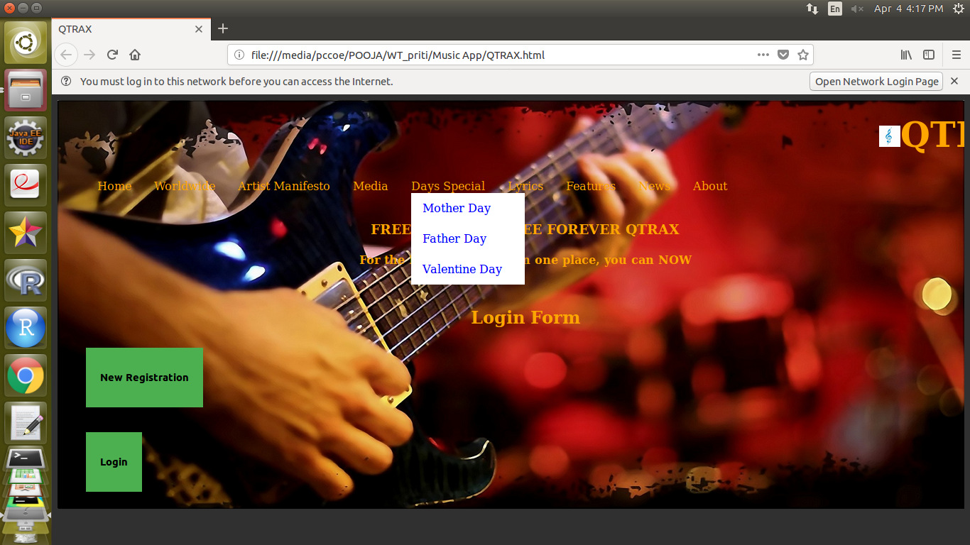

**Assignment 2**

**Homepage.html**

<html>

<head>

<link rel="stylesheet" href="style1.css">

</head>

<body>

<h1><center>SAMSUNG REFRIGIRATORS </h1>

<div class="container">

<a href="registration.html"><button class="btn1">REGISTRATION</button></a>

<a href="login.html"><button class="btn2">LOGIN</button></a>

</div>

</body>

</html>

style1.css

body {

background-image:url("2.jpg");

background-repeat: no-repeat;

}

.container .btn1 {

position: absolute;

top: 60%;

left: 70%;

background-color: #555;

color: white;

font-size: 16px;

padding: 12px 24px;

border: none;

cursor: pointer;

border-radius: 5px;

text-align: center;

}

.container .btn2 {

position: absolute;

top: 60%;

left: 60%;

background-color: #555;

color: white;

font-size: 16px;

padding: 12px 24px;

border: none;

cursor: pointer;

border-radius: 5px;

text-align: center;

}

**registration.html**

<html>

<head>

<title> Registration Form </title>

<img src="5.jpg" align="right">

<h2 align="left" >REGISTRATION FORM</h2>

<link rel="stylesheet" href="style.css">

<script src="sample.js">

</script>

</head>

<form name='registration' onSubmit="return formValidation();">

First name:<br>

<input type="text" name="firstname" required ><br><br>

Last name:<br>

<input type="text" name="lastname" required><br><br>

DOB:<input type ="date" name="abc" max="1990-01-01"><br><br>

email:

<input type="email" name="email" required><br><br>

mobile:

<input type="number" name="mobile"><br><br>

address:

<input type="text" name="address"><br><br>

city:<select name="city">

<option value="pune">pune</option>

<option value="nagpur">nagpur</option>

<option value="nashik">nashik</option>

<option value="jaipur">jaipur</option>

</select><br><br>

state:<select name="state">

<option value="Maharashtra">Maharashtra</option>

<option value="gujrat">gujrat</option>

<option value="rajasthan">rajasthan</option>

<option value="Madhya pradesh">madhya pradesh</option>

</select><br><br>

country:<select name="country">

<option value="India">India</option>

<option value="USA">USA</option>

<option value="UK">UK</option>

<option value="Africa">Africa</option>

</select><br><br>

<body>

<button onClick="formValidation()">Submit</button>

</body>

</form>

</html>

**sample.js**

function formValidation()

{

var first = document.registration.firstname;

var last = document.registration.lastname;

var uemail = document.registration.email;

var city = document.registration.city;

var state = document.registration.state;

var ucountry = document.registration.country;

if(first_validation(first,5,20))

{

if(last_validation(last,6,20))

{

if(cityselect(city))

{

if(stateselect(state))

{

if(countryselect(ucountry))

{

}

}

}

}

}

return false;

}

function first_validation(first,mx,my)

{

var first_len = first.value.length;

if (first_len == 0 || first_len >= my || first_len < mx)

{

alert("first name should not be empty / length be between "+mx+" to "+my);

first.focus();

return false;

}

return true;

}

function last_validation(last,mx,my)

{

var last_len = last.value.length;

if (last_len == 0 || last_len >= my || last_len < mx)

{

alert("last name should not be empty / length be between "+mx+" to "+my);

last.focus();

return false;

}

return true;

}

function cityselect(city)

{

if(city.value == "Default")

{

alert('Select your country from the list');

city.focus();

return false;

}

function stateselect(state)

{

if(state.value == "Default")

{

alert('Select your country from the list');

state.focus();

return false;

}

function countryselect(ucountry)

{

if(ucountry.value == "Default")

{

alert('Select your country from the list');

ucountry.focus();

return false;

}

**login.html**

<html>

<head>

<link rel="stylesheet" href="style.css">

</head>

<body>

<h1><center>LOGIN </h1>

</body>

<form>

Username:

<input type="text" name="Username" required><br><br>

Password:

<input type="text" name="Password" required ><br><br>

</form>

</html>

**style.css**

body {

background-color:grey;

background-repeat: no-repeat;

}

h3{

text-align:center

}

* {

box-sizing: border-box;

}

input{

width: 15%;

padding: 10px;

border: 1px solid #ccc;

border-radius: 4px;

box-sizing: border-box;

resize: vertical;

}

input select{

width: 15%;

padding: 10px;

border: 1px solid #ccc;

border-radius: 4px;

box-sizing: border-box;

resize: vertical;

}

input[type=date],[type=number], select{

width: 15%;

padding: 10px;

border: 1px solid #ccc;

border-radius: 4px;

box-sizing: border-box;

resize: vertical;

}

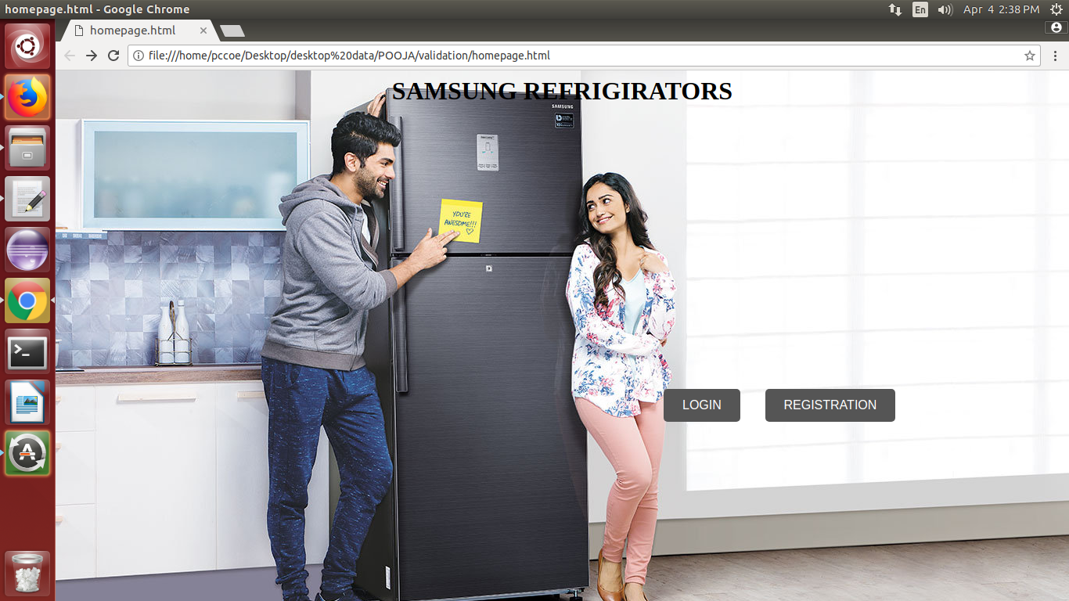

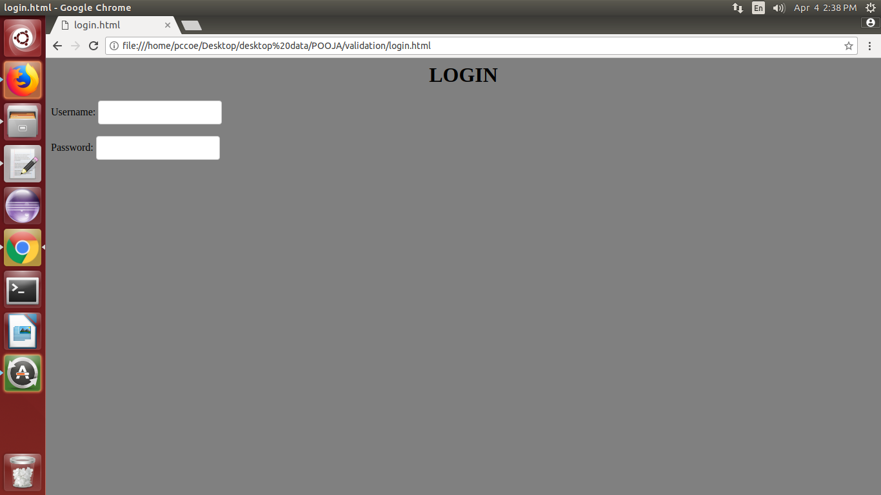

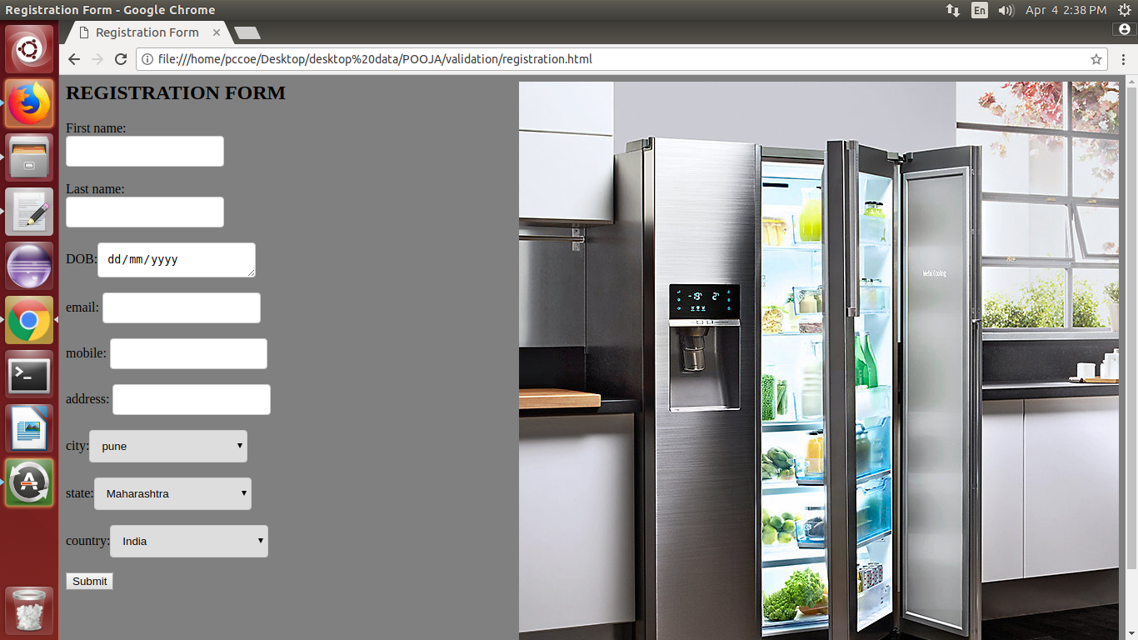

**Assignment No-3**

**form1.html**

**<html>**

<head>

<title>

Form

</title>

<script src=*"https://ajax.googleapis.com/ajax/libs/jquery/3.3.1/jquery.min.js"*></script>

<script src=*"https://cdnjs.cloudflare.com/ajax/libs/jquery-validate/1.17.0/jquery.validate.js"*></script>

<script src=*"assg2.js"* type=*"text/javascript"*></script>

<link rel=*"stylesheet"* href=*"assg2.css"*>

</head>

<body>

<div class=*"form2"*>

<form name=*"myform"* id=*"form11"* action=*"http://localhost:8080/svc/Servlet"* method=*"get"*>

<!-- <form name="myform" id="form11" action="s.jsp" method=post> -->

Name:<br><input type=*"text"* name=*"name1"* placeholder=*"Enter Name"* ><br>

Password:<br><input type=*"password"* name=*"pass12"* id=*"pass12"* placeholder=*"Enter password"* required><br>

Confirm Password:<br><input type=*"password"* name=*"pass2"* id=*"pass2"* placeholder=*"Confirm password"* required><br>

Mobile No:<br><input type=*"text"* name=*"mobnum"* pattern=*"[0-9]{10}"* placeholder=*"Enter Mobile No"* ><br>

Email Id:<br><input type=*"text"* placeholder=*"Enter Mail"* pattern=*"[A-Za-z0-9]+@[^@]+\.[a-zA-Z]{2,6}"* name=*"email1"* ><br>

Gender:male<input type=*"radio"* name=*"gender"* value=*"male"*>

female<input type=*"radio"* name=*"gender"* value=*"female"* ><br>

Hobbies:<input type=*"checkbox"* name=*"sport"* value=*"sport"*> sport

<input type=*"checkbox"* name=*"music"* value=*"music"*> music

<input type=*"checkbox"* name=*"other"* value=*"other"*> other<br>

state: <select>

<option value=*"Maharashtra"*>Maharashtra</option>

<option value=*"Punjab"*>Punjab</option>

<option value=*"Gujarat"*>Gujarat</option>

<option value=*"Other"*>Other</option>

</select><br>

pin:<input type=*"number"* name=*"pin"* ><br>

<input type=*"submit"* value=*"Submit"* id=*"submit1"* >

</form>

</div>

</body>

</html>

**Servlet.java**

**import** java.io.IOException;

**import** java.io.PrintWriter;

**import** java.sql.DriverManager;

**import** java.sql.Statement;

**import** javax.servlet.ServletException;

**import** javax.servlet.annotation.WebServlet;

**import** javax.servlet.http.HttpServlet;

**import** javax.servlet.http.HttpServletRequest;

**import** javax.servlet.http.HttpServletResponse;

**import** com.mysql.jdbc.Connection;

/**

* Servlet implementation class Servlet

*/

@WebServlet("/Servlet")

**public** **class** Servlet **extends** HttpServlet {

**private** **static** **final** **long** ***serialVersionUID*** = 1L;

**public** **static** **final** String ***url***="jdbc:mysql://localhost:3306/student";

**public** **static** **final** String ***username***="";

**public** **static** **final** String ***password***="";

/**

* **@see** HttpServlet#HttpServlet()

*/

**public** Servlet() {

**super**();

// **TODO** Auto-generated constructor stub

}

/**

* **@see** HttpServlet#doGet(HttpServletRequest request, HttpServletResponse response)

*/

**protected** **void** doGet(HttpServletRequest request, HttpServletResponse response) **throws** ServletException, IOException {

// **TODO** Auto-generated method stub

response.getWriter().append("Served at: ").append(request.getContextPath());

PrintWriter out=response.getWriter();

response.setContentType("text/html"); //for reading obj from server and displaying client understandable format.

**try**

{

Class.*forName*("com.mysql.jdbc.Driver");

Connection conn=(Connection) DriverManager.*getConnection*(***url***, ***username***, ***password***);

//either cast or import java.sql.connection;

out.println("<h1>successful</h1>"); //if connection is successfully established.

String name=request.getParameter("name1");

String pass=request.getParameter("pass12");

Statement st=conn.createStatement();

**int** i=st.executeUpdate("insert into stud values('"+name+"','"+pass+"');");

**if**(i<0)

{

out.println("Failure");

}

**else**

{

out.println("Values Successfully inserted");

}

}

**catch**(Exception e)

{

out.println("<h2>Exception: " + e + "</h2>");

}

}

/**

* **@see** HttpServlet#doPost(HttpServletRequest request, HttpServletResponse response)

*/

**protected** **void** doPost(HttpServletRequest request, HttpServletResponse response) **throws** ServletException, IOException {

// **TODO** Auto-generated method stub

doGet(request, response);

}

}

**OUTPUT-**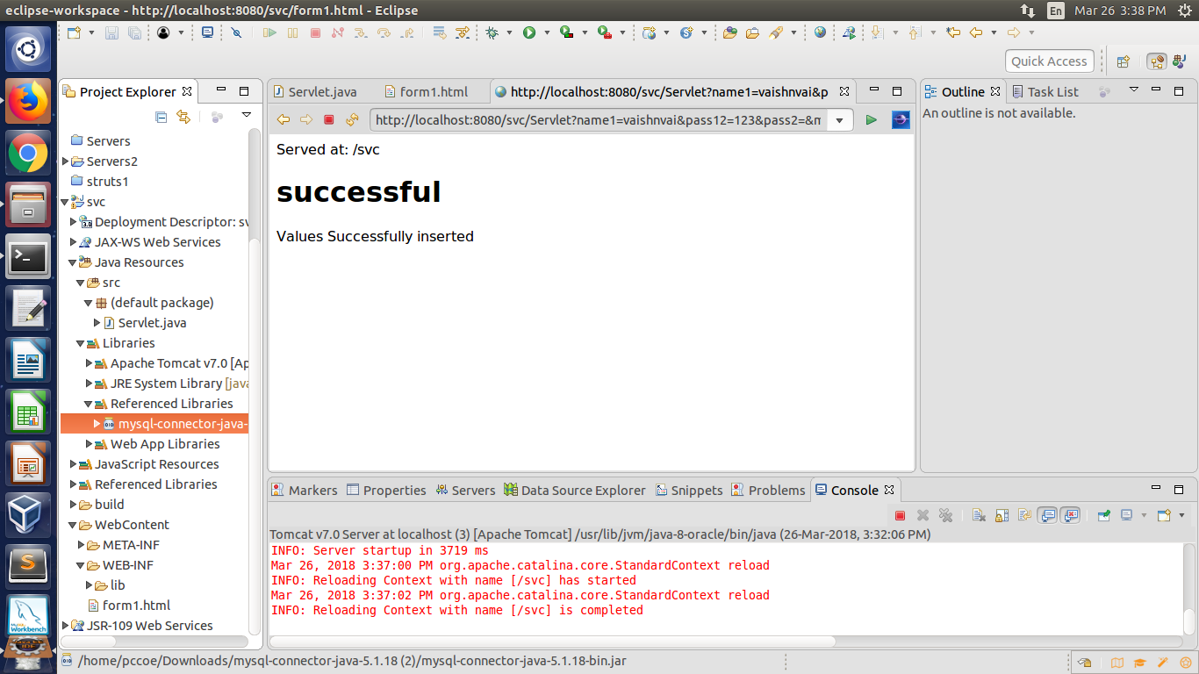

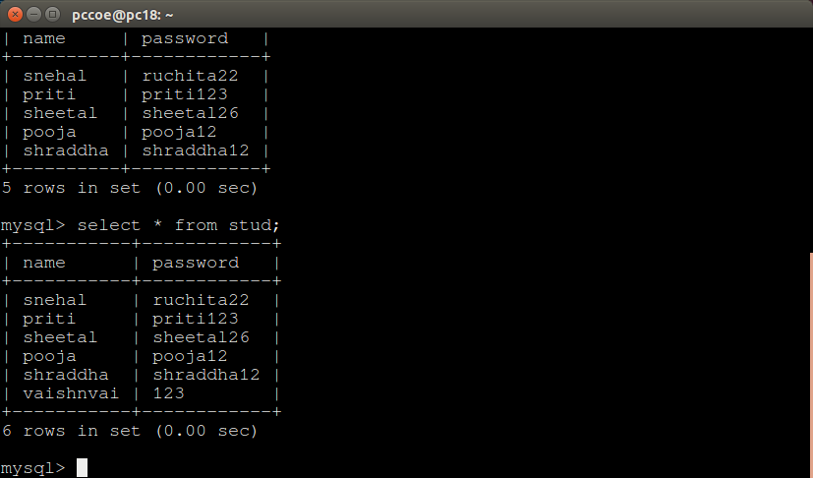

**s.jsp**

**<%@page import=*"com.mysql.jdbc.Connection"*%>**

<%@ page language=*"java"* contentType=*"text/html; charset=UTF-8"*

pageEncoding=*"UTF-8"*%>

<!DOCTYPE html PUBLIC "-//W3C//DTD HTML 4.01 Transitional//EN" "http://www.w3.org/TR/html4/loose.dtd">

<%@page import=*"java.io.IOException"*%>

<%@page import=*"java.io.PrintWriter"* %>

<%@page import=*"java.sql.DriverManager"* %>

<%@page import=*"java.sql.Statement"*%>

<%@page import=*"javax.servlet.ServletException"*%>

<%@page import=*"javax.servlet.annotation.WebServlet"*%>

<%@page import=*"javax.servlet.http.HttpServlet"*%>

<%@page import=*"javax.servlet.http.HttpServletRequest"*%>

<%@page import=*"javax.servlet.http.HttpServletResponse"*%>

<html>

<head>

<meta http-equiv=*"Content-Type"* content=*"text/html; charset=UTF-8"*>

<title>Insert title here</title>

</head>

<body>

<% String url="jdbc:mysql://localhost:3306/student";

String username="";

String password="";

**try**

{

Class.forName("com.mysql.jdbc.Driver");

Connection conn=(Connection) DriverManager.getConnection(url, username, password);

//either cast or import java.sql.connection;

out.println("<h1>successful</h1>"); //if connection is successfully established.

String name=request.getParameter("name1");

String pass=request.getParameter("pass12");

Statement st=conn.createStatement();

**int** i=st.executeUpdate("insert into stud values('"+name+"','"+pass+"');");

**if**(i<0)

{

out.println("Failure");

}

**else**

{

out.println("Values Successfully inserted into database");

}

}

**finally**

{

}

%>

</body>

</html>

**OUTPUT-**

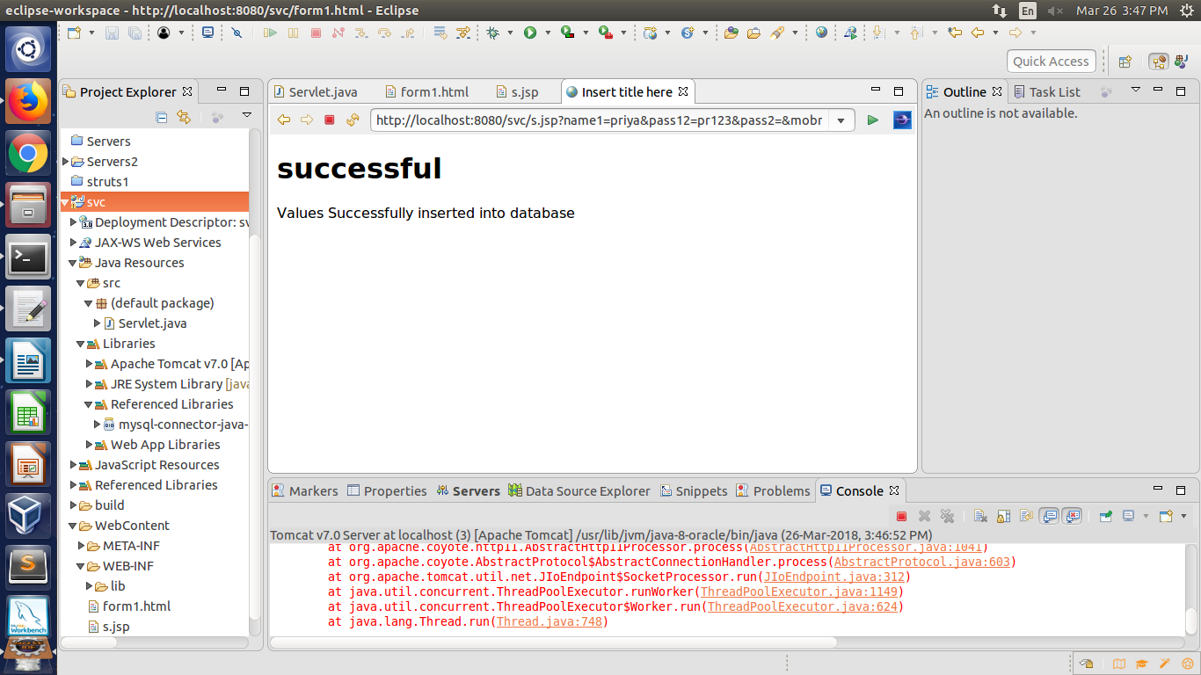

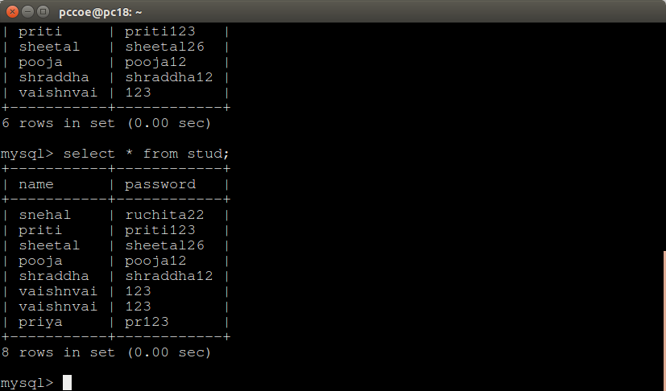

**ASSIGNMENT NO-4**

**form1.html**

<html>

<head>

<title>

Form

</title>

<script src="https://ajax.googleapis.com/ajax/libs/jquery/3.3.1/jquery.min.js"></script>

<script src="https://cdnjs.cloudflare.com/ajax/libs/jquery-validate/1.17.0/jquery.validate.js"></script>

<script src="assg2.js" type="text/javascript"></script>

<link rel="stylesheet" href="assg2.css">

</head>

<body>

<div class="form2">

<!-- <form name="myform" id="form11" action="http://localhost:8080/TEA120/Servlet" method=post> -->

<form name="myform" id="form11" action="h1.php" method=post>

Name:<br><input type="text" name="name1" placeholder="Enter Name" ><br>

Password:<br><input type="password" name="pass12" id="pass12" placeholder="Enter password" required><br>

Confirm Password:<br><input type="password" name="pass2" id="pass2" placeholder="Confirm password" required><br>

Mobile No:<br><input type="text" name="mobnum" pattern="[0-9]{10}" placeholder="Enter Mobile No" required><br>

Email Id:<br><input type="text" placeholder="Enter Mail" pattern="[A-Za-z0-9]+@[^@]+\.[a-zA-Z]{2,6}" name="email1" required><br>

Gender:male<input type="radio" name="gender" value="male">

female<input type="radio" name="gender" value="female" ><br>

Hobbies:<input type="checkbox" name="sport" value="sport"> sport

<input type="checkbox" name="music" value="music"> music

<input type="checkbox" name="other" value="other"> other<br>

state: <select>

<option value="Maharashtra">Maharashtra</option>

<option value="Punjab">Punjab</option>

<option value="Gujarat">Gujarat</option>

<option value="Other">Other</option>

</select><br>

pin:<input type="number" name="pin" required><br>

<input type="submit" value="Submit" id="submit1" >

</form>

</div>

</body>

</html>

**h1.php**

<?php

$servername="localhost";

$username="";

$password="";

$dbname="student";

$conn=new mysqli($servername,$username,$password,$dbname);

if($conn->conn_error)

{

die("Connection failed: ".$conn->connect_error);

}

echo "connected successfully";

$name=$_POST["name1"];

$pass=$_POST["pass12"];

$sql = "INSERT INTO stud VALUES('$name','$pass') ";

if ($conn->query($sql) === TRUE) {

echo "<br>New record created successfully<br>";

} else {

echo "Error: " . $sql . "<br>" . $conn->error;

}

$sql1="SELECT * FROM stud";

$result = $conn->query($sql1);

if ($result->num_rows > 0) {

while($row = $result->fetch_assoc()) {

echo "<br> Name: " . $row["name"]. " " ."\tPass: ". $row["password"]. "<br>";

}

} else {

echo "0 results";

}

$sql2 = "DELETE FROM stud WHERE name='vaishnavi'";

if ($conn->query($sql2) === TRUE) {

echo "<br>Record deleted successfully";

} else {

echo "Error deleting record: " . $conn->error;

}

$sql3 = "UPDATE stud SET password='ruchita22' WHERE name='snehal'";

if ($conn->query($sql3) === TRUE) {

echo "<br>Record updated successfully";

} else {

echo "Error updating record: " . $conn->error;

}

?>

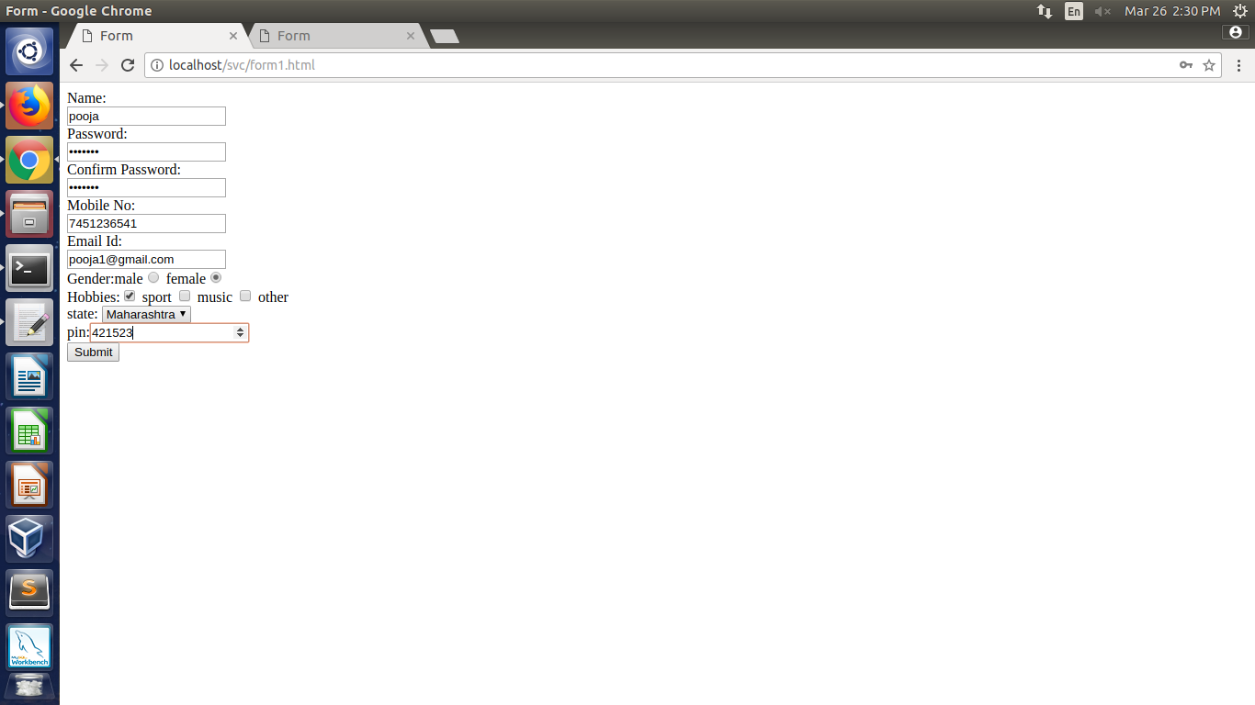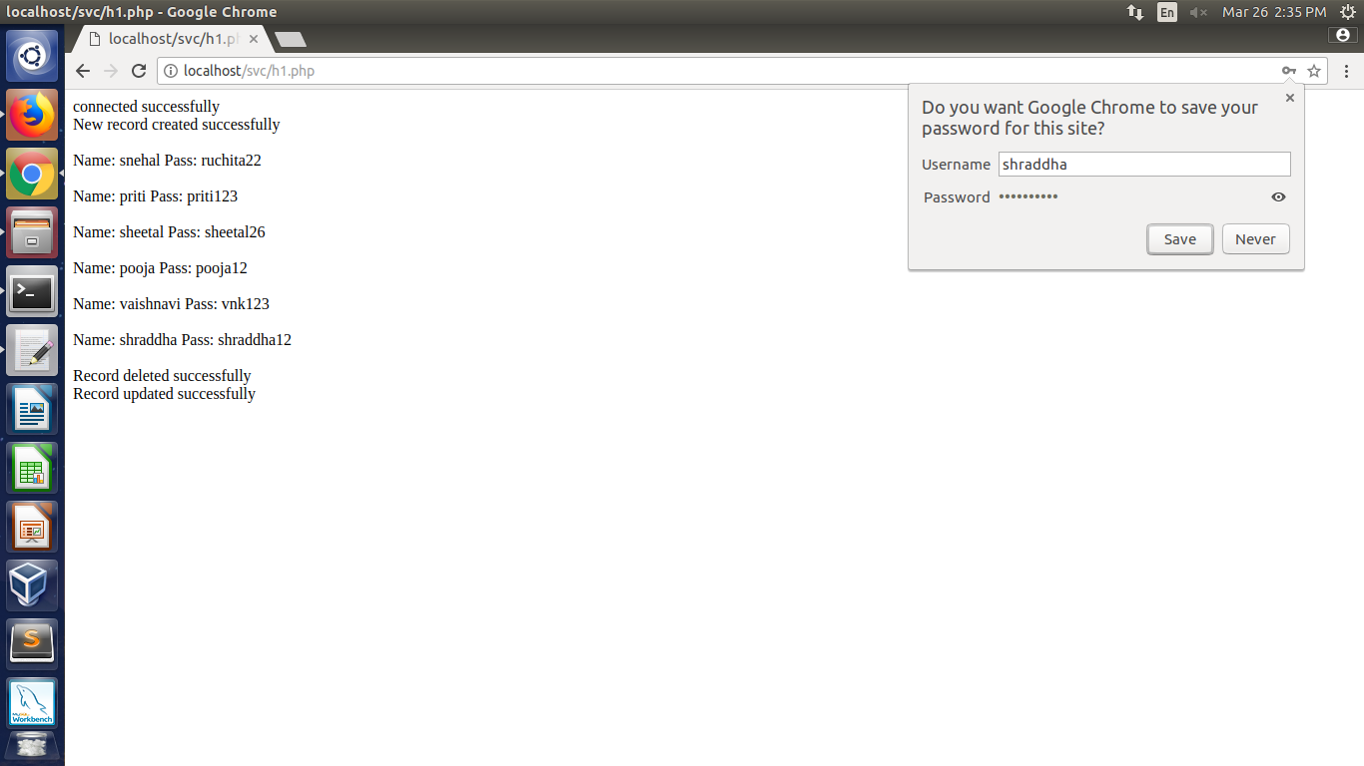

**\**

**Assignment no 5**

**LoginAction.java**

import java.sql.Connection;

import java.sql.DriverManager;

import java.sql.PreparedStatement;

import java.sql.ResultSet;

import com.opensymphony.xwork2.ActionSupport;

public class LoginAction extends ActionSupport {

/**

*

*/

private static final long serialVersionUID = 1L;

private String user;

private String password;

private String name;

public String execute() {

String ret = ERROR;

Connection conn = null;

try {

String URL = "jdbc:mysql://localhost:3306/mysql";

Class.forName("com.mysql.jdbc.Driver");

conn = DriverManager.getConnection(URL+"?useSSL=false", "root", "S99709970");

String sql = "SELECT name FROM user1 WHERE";

sql+=" name = ? AND pass = ?";

PreparedStatement ps = conn.prepareStatement(sql);

ps.setString(1, user);

ps.setString(2, password);

ResultSet rs = ps.executeQuery();

while (rs.next()) {

name = rs.getString(1);

ret = SUCCESS;

}

} catch (Exception e) {

ret = ERROR;

} finally {

if (conn != null) {

try {

conn.close();

} catch (Exception e) {

}

}

}

return ret;

}

public String getUser() {

return user;

}

public void setUser(String user) {

this.user = user;

}

public String getPassword() {

return password;

}

public void setPassword(String password) {

this.password = password;

}

public String getName() {

return name;

}

public void setName(String name) {

this.name = name;

}

}

Struts.xml

<?xml version="1.0" encoding="UTF-8"?>

<!DOCTYPE struts PUBLIC

"-//Apache Software Foundation//DTD Struts Configuration 2.0//EN"

"http://struts.apache.org/dtds/struts-2.0.dtd">

<struts>

<package name = "" extends = "struts-default">

<action name = "loginaction"

class = "LoginAction"

method = "execute">

<result name = "success">/success.jsp</result>

<result name = "error">/error.jsp</result>

</action>

</package>

</struts>

web.xml

<?xml version="1.0" encoding="UTF-8"?>

<web-app xmlns:xsi = "http://www.w3.org/2001/XMLSchema-instance"

xmlns = "http://java.sun.com/xml/ns/javaee"

xmlns:web = "http://java.sun.com/xml/ns/javaee/web-app_2_5.xsd"

xsi:schemaLocation = "http://java.sun.com/xml/ns/javaee

http://java.sun.com/xml/ns/javaee/web-app_3_0.xsd"

id = "WebApp_ID" version = "3.0">

<display-name>Struts 2</display-name>

<welcome-file-list>

<welcome-file>index.jsp</welcome-file>

</welcome-file-list>

<filter>

<filter-name>struts2</filter-name>

<filter-class>

org.apache.struts2.dispatcher.filter.StrutsPrepareAndExecuteFilter

</filter-class>

</filter>

<filter-mapping>

<filter-name>struts2</filter-name>

<url-pattern>/*</url-pattern>

</filter-mapping>

</web-app>

error.jsp

<%@ page contentType = "text/html; charset = UTF-8" %>

<%@ taglib prefix = "s" uri = "/struts-tags" %>

<html>

<head>

<title>Invalid User Name or Password</title>

</head>

<body>

Wrong user name or password provided.

</body>

</html>

Index.jsp

<%@ page language = "java" contentType = "text/html;

charset = ISO-8859-1"

pageEncoding = "ISO-8859-1"%>

<%@ taglib prefix = "s" uri = "/struts-tags"%>

<!DOCTYPE html PUBLIC "-//W3C//DTD HTML 4.01 Transitional//EN"

"http://www.w3.org/TR/html4/loose.dtd">

<html>

<head>

<title>Login</title>

</head>

<body>

<form action = "loginaction" method = "post">

User:<br/><input type = "text" name = "user"/><br/>

Password:<br/><input type = "password" name = "password"/><br/>

<input type = "submit" value = "Login"/>

</form>

</body>

success.jsp

<%@ page contentType = "text/html; charset = UTF-8" %>

<%@ taglib prefix = "s" uri = "/struts-tags" %>

<html>

<head>

<title>Successful Login</title>

</head>

<body>

Hello World, <s:property value = "name"/>

</body>

</html>

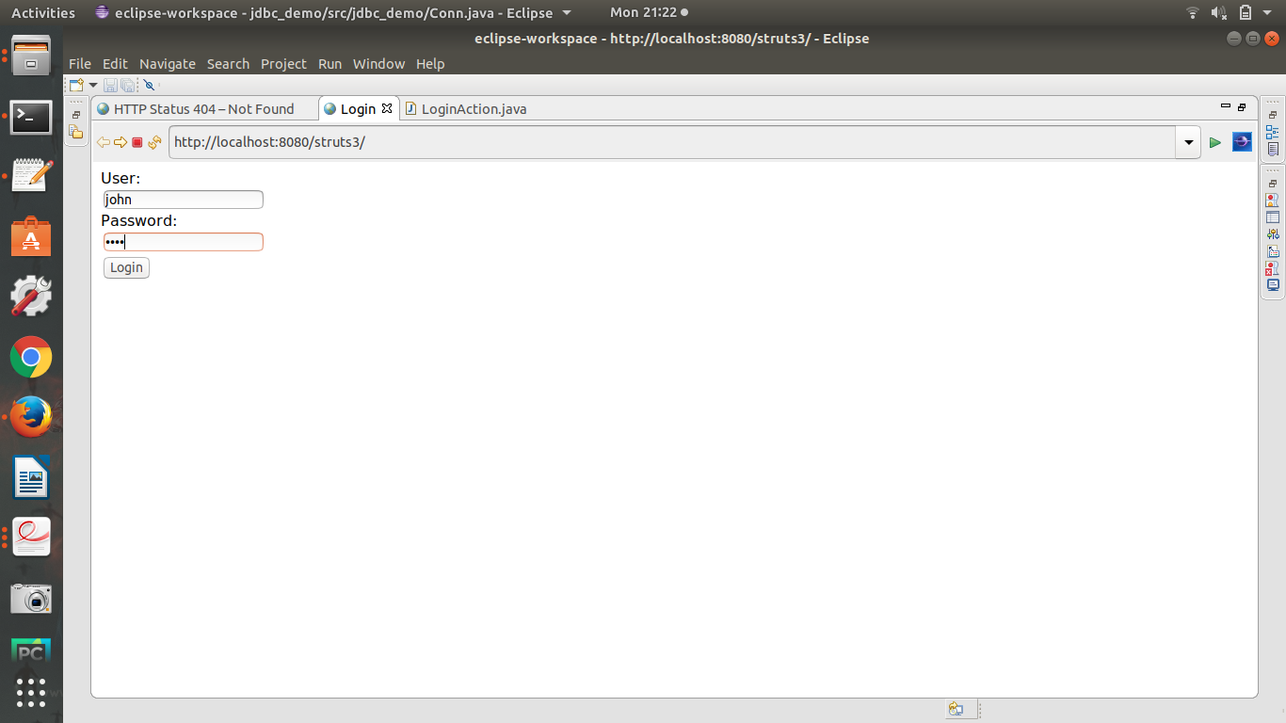

**Assignment 6**

**AngularJS**

**aa.html**

<!DOCTYPE html>

<html >

<style>

table, th , td {

border: 1px solid grey;

border-collapse: collapse;

padding: 5px;

}

table tr:nth-child(odd) {

background-color: #f1f1f1;

}

table tr:nth-child(even) {

background-color: #ffffff;

}

</style>

<script src="https://ajax.googleapis.com/ajax/libs/angularjs/1.6.4/angular.min.js"></script>

<body>

<div ng-app="myApp" ng-controller="customersCtrl">

<table>

<tr ng-repeat="x in names">

<td>name: {{ x.name }}</td>

<td>email: {{ x.email }}</td>

</tr>

</table>

</div>

</body>

<script>

var app = angular.module('myApp', []);

app.controller('customersCtrl', function($scope, $http) {

$http.get("a.php")

.then(function (response) {$scope.names = response.data.records;});

});

</script>

</html>

**a.php**

<?php

header("Access-Control-Allow-Origin: *");

header("Content-Type: application/json; charset=UTF-8");

$conn = new mysqli("localhost", "", "","pccoe");

$result = $conn->query("SELECT name, email FROM user");

//while ($row = mysqli_fetch_array($result)) {

//$data[] = array("Name"=>$row['name'],"EMail"=>$row['email']);

//}

//echo json_encode($data);

$outp = "";

while($rs = $result->fetch_array(MYSQLI_ASSOC)) {

if ($outp != "") {$outp .= ",";}

$outp .= '{"name":"' . $rs["name"] . '",';

$outp .= '"email":"'. $rs["email"] . '"}';

}

$outp ='{"records":['.$outp.']}';

$conn->close();

echo($outp);

?>

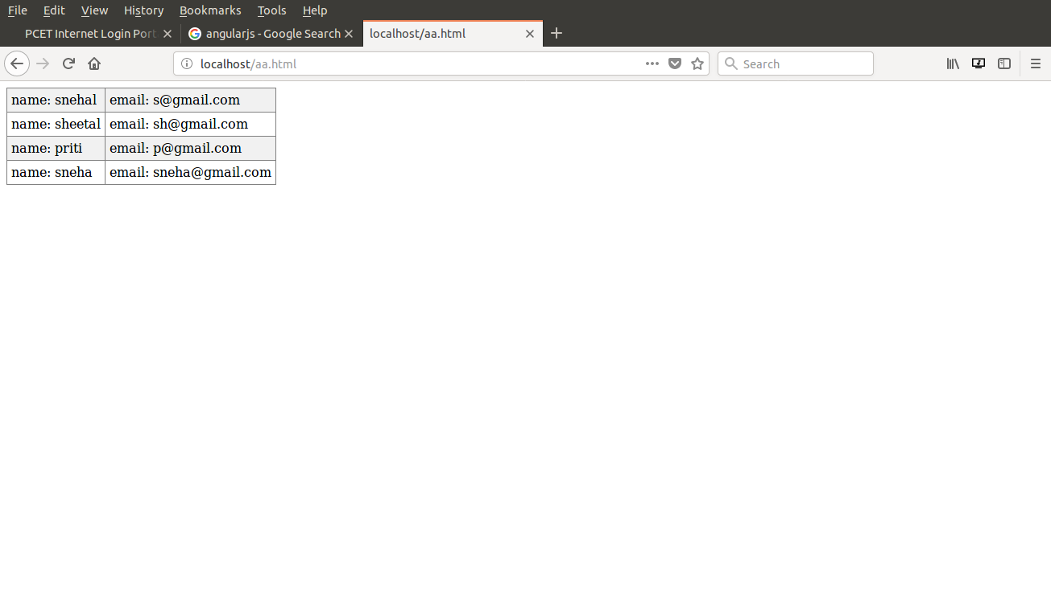

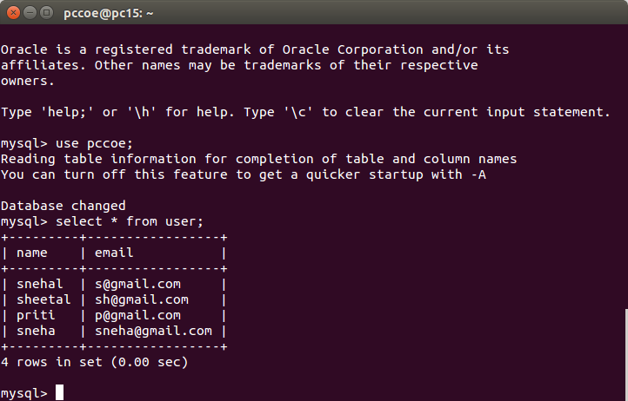

**Assignment No 7**